**ES_HW00_109598061**

**廖昱翔**

**Part 1 : Installation result**

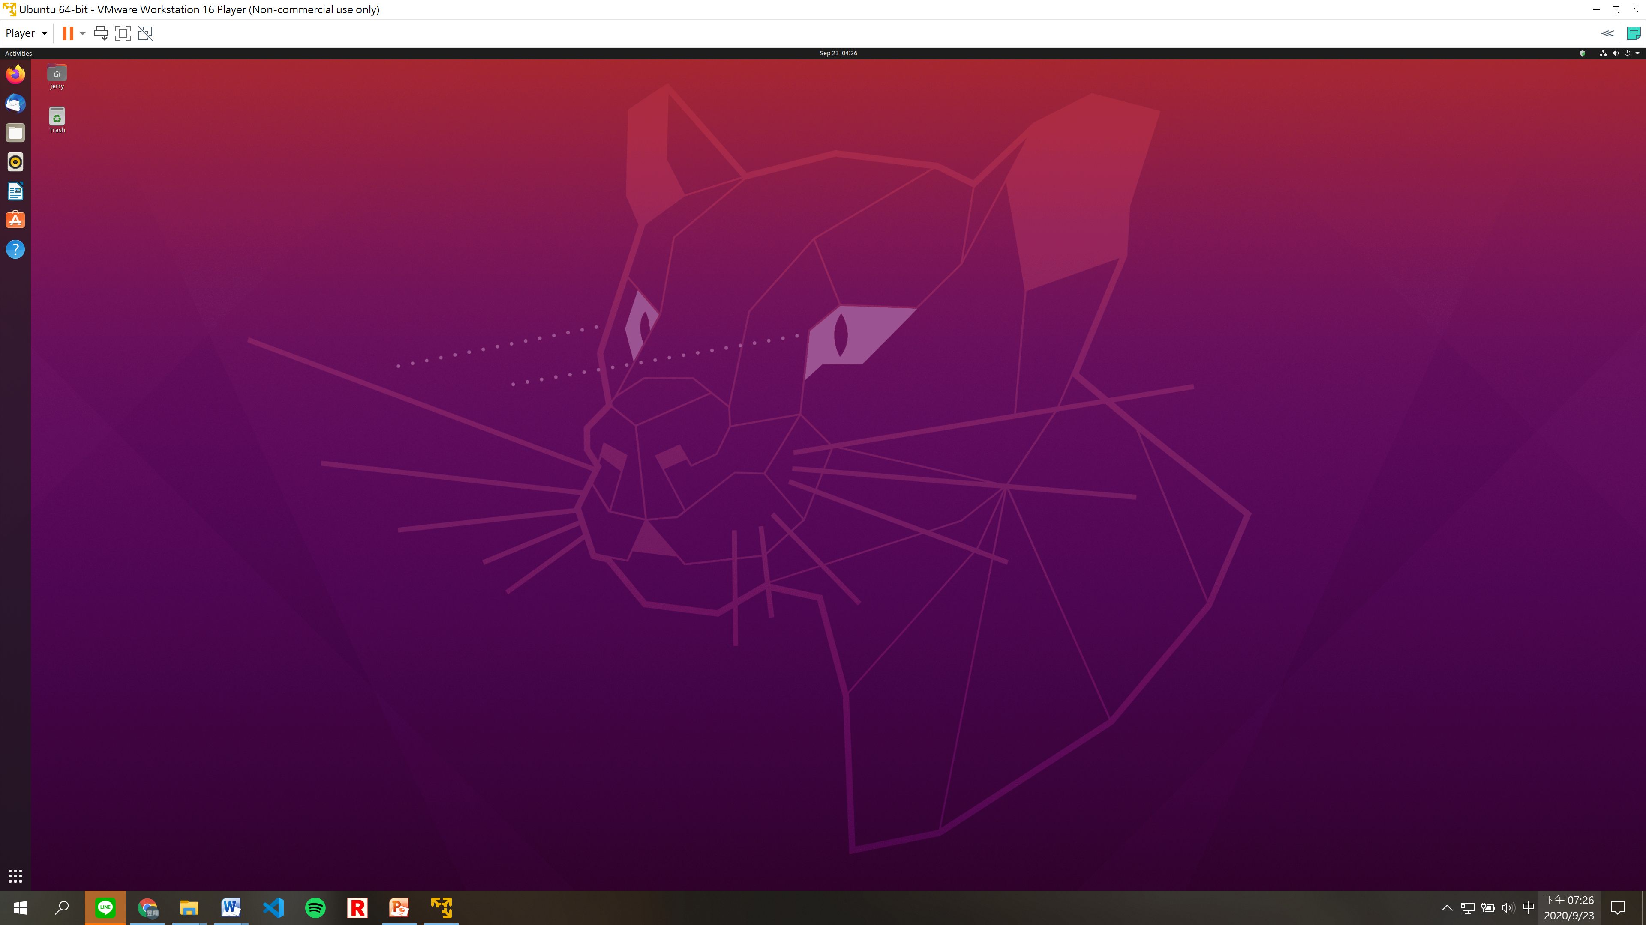

**Format Guide**:

1. Except caption, the content should be set with row height of 20 points, align to the left.
2. Caption format: 18pt and Bold font.
3. Font format: Times New Roman.
4. Figure: Center with single line row height
5. Please upload pdf file with the file name format : **ES_HW00_109000000**
6. Please remove the line starting with // and the format guide part.
7. Grading Policy of HW00: Correct format 80% and Installation result 20%.